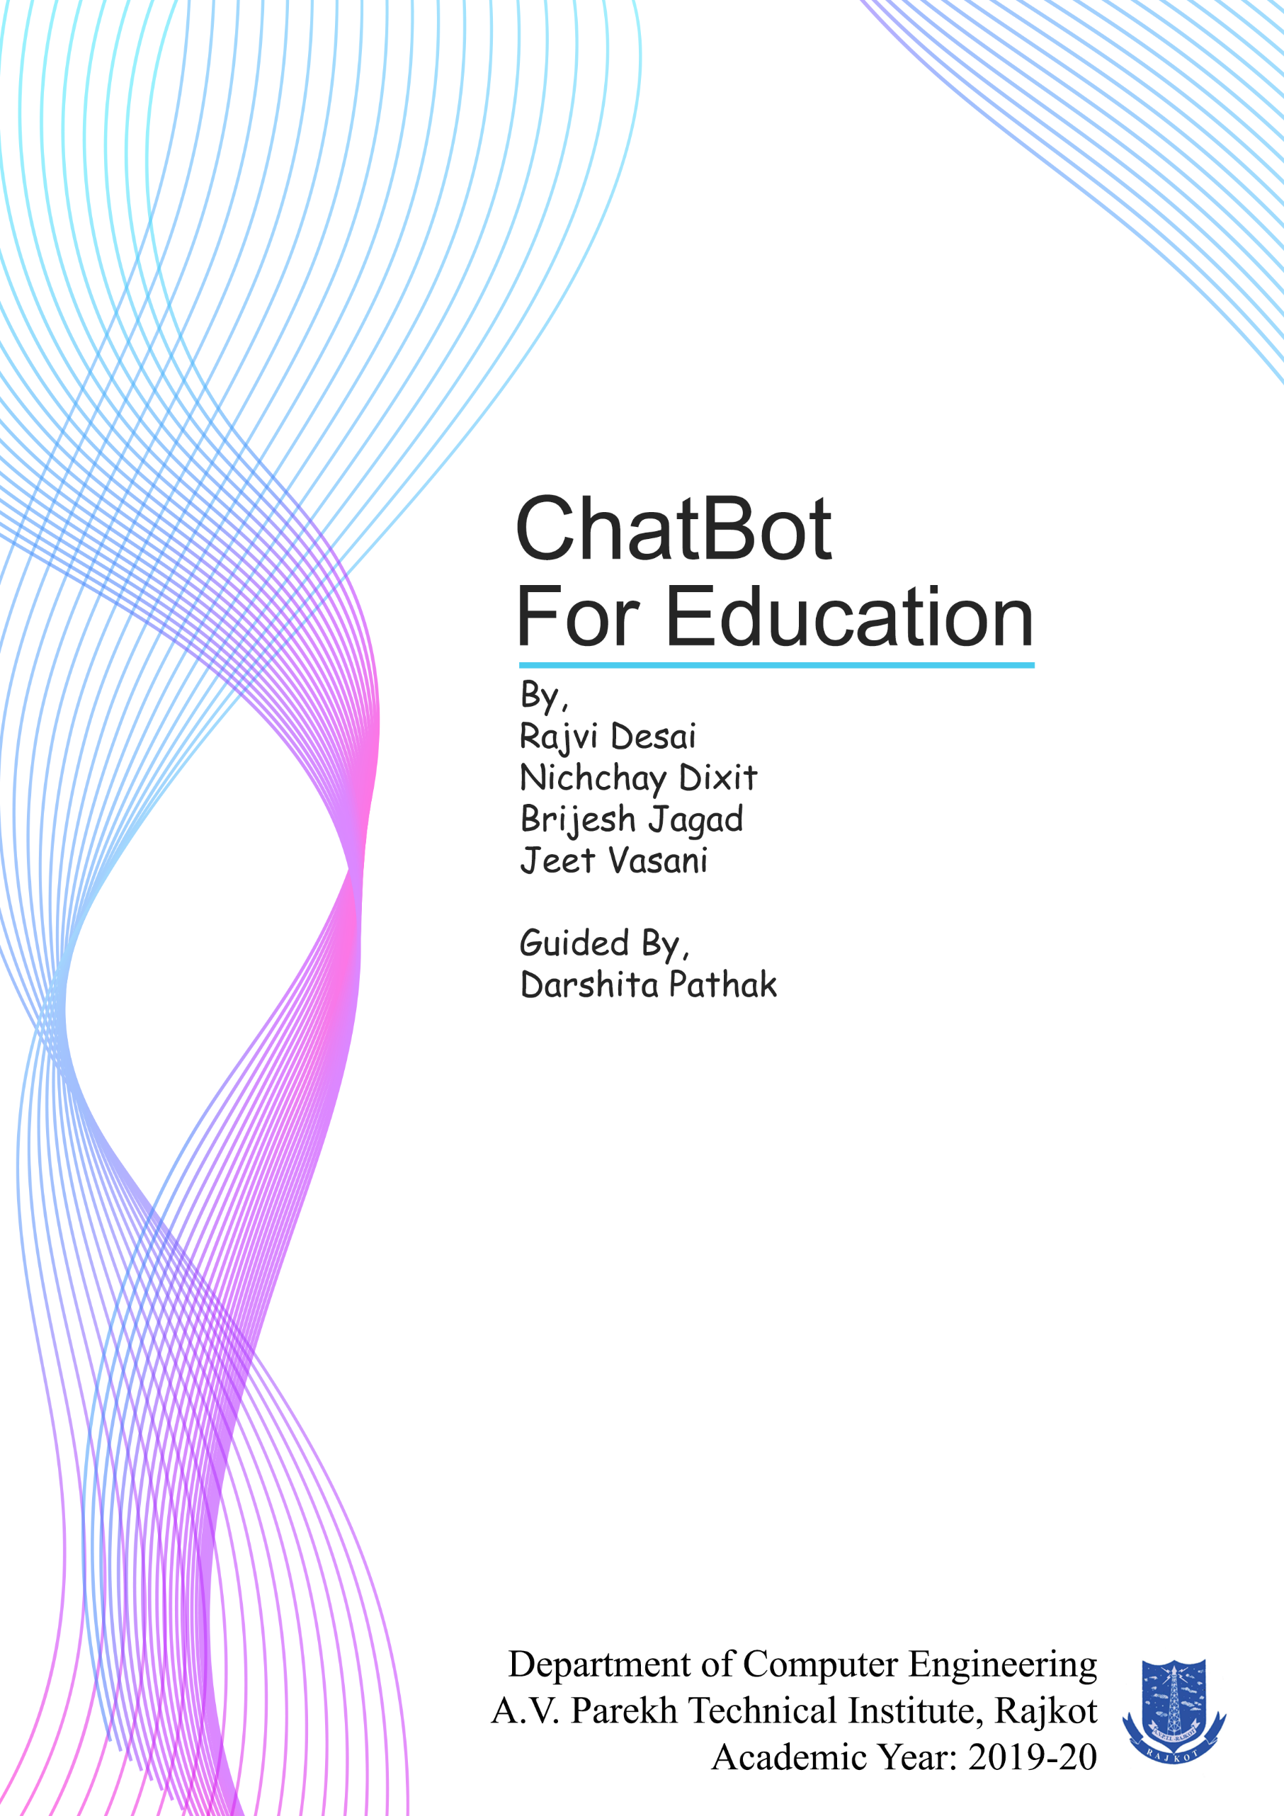

**DETAILS OF CHAPTERS**

* ***Abstract***

1. **Introduction**
   1. Characteristics of System
   2. Overview of This System
   3. Scope (Scope- List of Modules and their Functions)
   4. Process model – (Describe the process model with Reason)
2. **System Requirements Specification**
   1. User characteristics
   2. Functional requirements
   3. Non-Functional requirements
3. **System Analysis Modelling**
   1. Feasibility Study
   2. User-Based Modelling
      1. Use Case Diagrams
4. **System Analysis and Design-Data Based**
   1. Data Modelling
      1. Data Dictionary (List of Database Tables included in the system)
      2. E-R (Entity Relationship) Diagram
   2. Behavioural Modelling
      1. Data Flow Diagram
         1. Context Level Diagram (Level 0)
         2. DFD - Level 1
         3. DFD - Level 2
5. **System Design – UML**
   1. Sequence Diagrams
   2. Activity Diagrams
6. **System Interface Design**
   1. Graphical User Interface Design (Input-Output Forms)

**ABSTRACT**

The main objective of this system is to provide a Virtual Assistant(chatbot) for admission guidance after 10th Board. This System will guide users by providing various functionalities like a chatbot for virtual interaction, information of various streams and of the various schools and colleges for helping users to find the most suitable for them.

Problem with the current scenario is students/parents need to manually visit the school/college to get their queries answered by the school/college help desk. This process consumes a lot of time as some of students/parents needed to visit schools/colleges and some of them are far away from their residence. Also, this process may lead to a communication gap between student and school/college. This problem can be overcome with this system.

This project is intended for students and parents who are currently having dilemmas about carrier and future scope for choosing a particular stream based on their preferences.

**Tools Technologies**: -

Android Studio, Java, PHP, Adobe XD

1. **INTRODUCTION**

**1.1 CHARACTERISTICS OF THIS SYSTEM**

1. The chatbot can prompt the user with a menu of options, sometimes based on previous interactions.
2. When students don’t find what to do after 10th Standard the system can help them with proper guidance for educational streams after 10th Standard.
3. The system provides all information at one place (about steams, schools/colleges).
4. The system is much efficient to give appropriate guidance to the user via chatbot which works as a virtual guide.
5. The user finds very much convenient to operate this application.

**1.2 OVERVIEW OF THIS SYSTEM**

* The System chatbot for education is designed to help students and other users to find the right stream after their 10th boards. In our System, the special functionality we are providing is the chatbot (A Virtual Guide). A Chatbot will work merely like a computer program that fundamentally simulates human conversations. It will allow a form of interaction between human and machine which will happen via messages. The chatbot we are providing is capable of interpreting messages and replying the user based on a combination of predefined scripts and the user input message/s.
* Other Functionalities we are providing are helpful for the User (Students) to find the best College Suitable for their chosen stream. The System is user friendly. The users can even give any kind of suggestions if they have through the FAQ Section. Moreover, the system consists of various functions like search filter, user profile update, privacy settings, display settings and FAQ for user convenience.
* Thus, the system is all about helping the user(student) to find the right path with the most suitable school/College in the best way.

**1.3 SCOPE (SCOPE-LIST OF MODULES AND THEIR FUNCTIONS)**

* This application is mainly useful for parents/students who are puzzled about the stream they want to choose form. This application will help then to identify their interested stream based on their criteria and their area of interest.
* This application is made under easy to use environment (the user will not have to suffer to find out their use full options).
* This application assembles all the information about streams, schools and colleges at one place.
* The user can register with basic details like their email id and name. Now user can use all the basic functions of the application.
* Using this application, the user will get seamless experience while accessing the content and data about college like College name, College address, Year of establishment, Title of the courses offered, Infrastructure/Teaching Facilities, URL of college's Website.
* The user gets virtual experience about the campus they searched for (i.e. images, VR, videos, etc…).
* This application will prompt users several suggested queries accordingly to their previous conversations. User can select the option according to their query or can raise a new query and get the output of his/her query.
* This system is much efficient to provide proper guidance to the user with a Chabot named *Demo* which will interact with the user to solve their queries related to choosing their stream or doubts about their chosen stream.

**1.4 PROCESS MODEL**

The Process Model that is being used in building this system is the **Prototype Model.**

**Prototype Model:**

The prototyping model is defined as the process of developing a working replication of a system that has to engineered.

Why we have chosen Prototype Model?

* Requirements are being added at each stage.
* Missing Functionalities and errors can be easily detected.
* As there can be fewer chances of error the overall time to build the project reduces.
* Prototypes can be reused in future.
* For getting a better understanding of the project.
* No later changes, a greater number of changes will be adapted during each phase of prototype preparation.

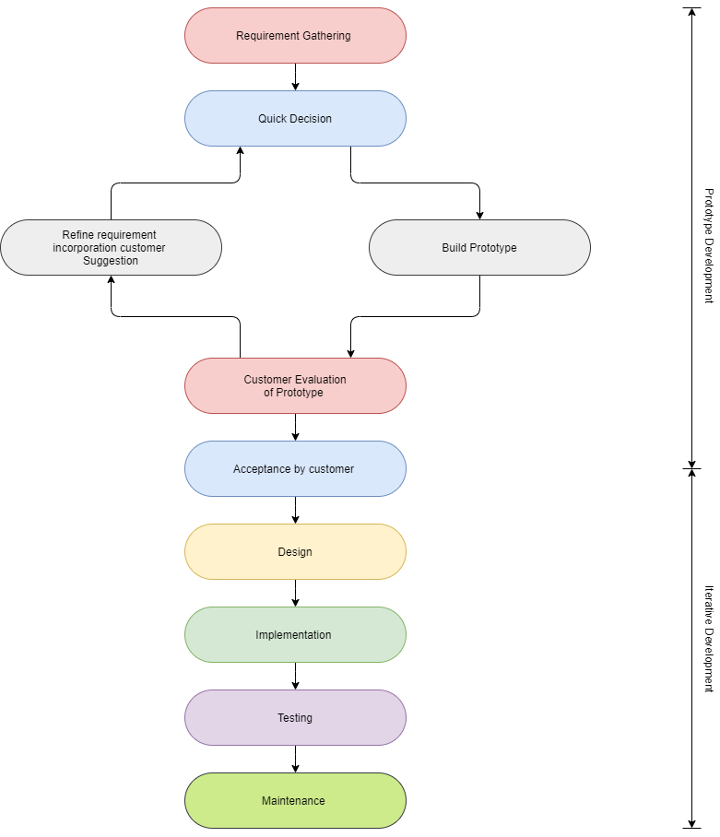

**Fig.** **Prototype Model**

**2.0 SRS**

**2.1 USER CHARACTERISTICS**

* **Type of Users:**

**Users**

1)Students

2)Visitors

3)Suggestion givers

4)Guests

**Admin**

1)Developers

2)Testers

**Characteristics of Users:**

1)If the user will log in to the system, we will provide them with more functionalities.

2)User can select the search function we can use the option to the user that choose the fields (Filters).

3)User can get information from many of the colleges of Gujarat through our application.

4)If user select details about the college, we can give relevant suggestions.

5)User can add their suggestions in the FAQ.

6)User can ask a question and the chatbot we are providing will give them reply.

**Characteristics of ADMIN:**

1)He can update system layout and features.

2)He checks and blocks user data if needed.

3)Admin provides the user to give feedback and review.

4)Admin asks for microphone permission.

**2.2 FUNCTIONAL REQUIREMENTS**

**2.2.1 Functional Requirements (User)**

**R.1: User Registration**

**Input:**

(Name, Email OR Phone, Password, Confirm Password)

OR Continue with Google, Facebook or Guest

**Output:**

OTP verification page

**Process**:

The user gets redirected to the validation page

**R.1.2: Register in process**

**Input:**

OTP

**Output:**

App home page

**Process:**

If OTP is correct then the user gets registered (OTP duration: 5 min)

**R.2: User Login**

**Input:**

User (Email ID or Mobile Number), Password

**Output:**

Redirect to Homepage

**Process:**

Verify and redirection (Validation)

**R.3: Chatbot**

**Input:**

Message by user

**Output:**

Reply by the chatbot

**Process:**

The chatbot will reply to the user based on the message he/she has sent

**R.4: Search Option**

**Input:**

Search Key entered by the user

**Output:**

Relevant pages (Containing the search key)

**Process:**

Through the entered search key this functionality will find the relevant content from the database

**R.5: Settings**

**R.5.1: My Account (Edit profile)**

**Input:**

User’s information

**Output:**

Updated Profile will be displayed and save to the database

**R.5.2: Display and Visibility**

**Input:**

Dark mode visibility, Font Size

**Output:**

Changes will be reflected in the application

**R.5.3: Chat History**

**Input:**

Click on Chat History

**Output:**

Chatbot Opens

**Process:**

The chatbot will be open with the previous chats

**R.5.4: Delete Account**

**Input:**

Click on Delete account

**Output:**

User Account will be deleted

**Process:**

User Account will be deleted and you will be log out from the session

**R.5.5: Help**

**Input:**

Application related queries

**Output:**

Solutions for the queries

**R.6: FAQ**

**Input:**

Search for query

**Output:**

Output to query

**R.7: Logout**

**Input:**

Click on Logout

**Output:**

User will be log out from the app

**2.2.2 Functional Requirement (Admin)**

**R.1: Login**

**Input:**

Admin ID, Password

**Output:**

Redirect to homepage

**Process:**

Validation

**R.2: Manage Users**

**R.2.1: Add User**

**Input:**

User details

**Output:**

User added successfully

**R.2.2: Remove User**

**Input:**

User ID

**Output:**

User Removed successfully

**R.3: Maintain College Information**

**R.3.1: Update College Information**

**Input:**

College ID, update information

**Output:**

Information updated successfully

**R.3.2: Add College Information**

**Input:**

College information

**Output:**

College information added successfully

**R.3.3: Remove College Information**

**Input:**

College ID

**Output:**

College removed successfully

**2.3 NON-FUNCTIONAL REQUIREMENTS:**

1. Availability

* The System is available for all users.

1. Usability

* It is very easy for the user to learn how to use the system and the time to learn is hardly 15 minutes.

1. Reliability

* The System is reliable and will not crash.
* The Bot replies to the user’s query under 30 Seconds.
* Talking to Bot feels like talking to a person (The Bot Should not reply instantly as it is not a human gesture, 2-3 Seconds Delay between responses).

1. Maintainability

* The Bot is designed in such a way that it can be maintained in future
* The system maintains User information.

1. Portability

* The application can be used in any android device.

1. Security

* The Private information of the users like their chat history, search history and the user data will be secure in this system.

1. **SYSTEM ANALYSIS MODELLING**
   1. **FEASIBILITY STUDY: -**

* **What is the feasibility?**

A feasibility study performed by a company when they want to know whether a project is possible given certain circumstances to find out whether a company has enough money for a project, to find out whether the product being created will sell, or to see if there are enough human resources for the project.

* **Here we have to discuss the following feasibilities: -**

1. Technical feasibility
2. Cost feasibility
3. Time feasibility
4. **Technical Feasibility: -**

* The application uses minimum system requirement that is available today in almost every android smartphone.
* The technical analysis evaluates the technical merits of the system at the same time collecting additional information about performance, reliability, maintainability, and productivity so by this we can say that application is technically feasible.
* This system requires minimum 512MB RAM and 80MB of free storage space available which nowadays easily available in most of the phones.

1. **Cost Feasibility: -**

* The feasibility study will examine the economic costs related to the project, including equipment or other resources, man-hours, the proposed benefits of the project, the break-even schedule for the project, the financial risks associated with the proposal.
* Among the most important information contained in the feasibility study is the cost-benefit analysis. That is an assessment of economics justification for a chatbot-based application.
* System developed by us cheaper as compared to resources needed. This is because most of the resources we were used are open-source and freeware.
* For this project, we have calculated all around cost including all resources, development time, Efforts, etc… of about ₹55,000.

1. **Time Feasibility: -**

* A time feasibility study will take into account the period in which the project is going to take up to its completion. A project will fail if it takes too long to be completed before it is useful.
* In our project, the estimated LOC is 9000(9KLOC). And our project is made with a smaller development team. So, the best COCOMO Model estimation technique we found was organic.
* For organic cost estimation, we have to find out the effort first.

Effort = 2.4(KLOC)^1.05 PM

Effort = 2.4(9) ^1.05 PM

Effort = 2.4 * 10.0451086 PM

**Effort = 24.1082606 PM**

* Now the formula for Time is:

TDev = 2.5(Effort)^0.38 Months

TDev = 2.5(24.1082606) ^0.38 Months

TDev = 2.5 * 3.35137506 Months

TDev = 8.37843765 Months

**TDev = ~ 8 Months**

* So, the development time we estimated was 8 Months.
  1. **USER-BASED MODELLING: -**

**Use Case Diagram: -**

1. **Guest Use-case:**

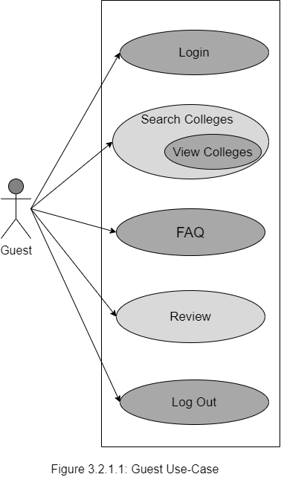

1. **User Use-case:**

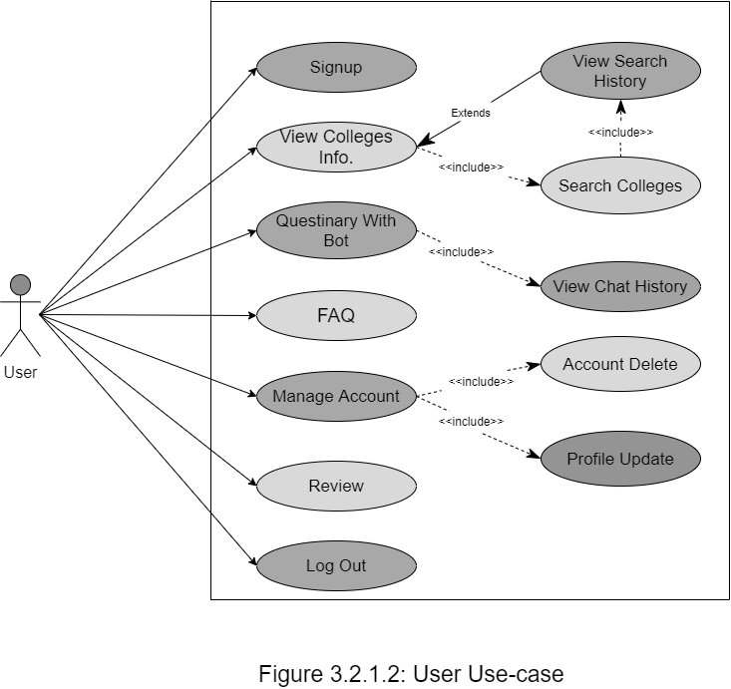

1. **Admin Use-Case:**

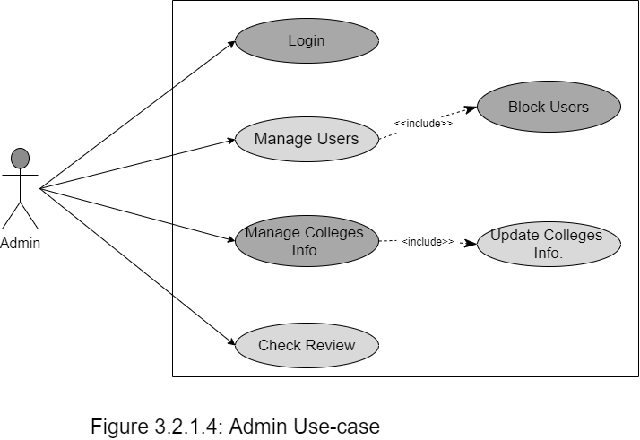

1. **SYSTEM ANALYSIS AND DESIGN – DATA BASED**

**4.1 DATA MODELING**

**4.1.1 Data Dictionary**

1. **User Details**

|  |  |  |  |
| --- | --- | --- | --- |
| **Sr. No** | **Field/s** | **Data Type** | **Constraint/s** |
| 1 | UID | Number | Primary, Auto-Increment |
| 2 | User_Name | Varchar | - |
| 3 | Email | Varchar | Primary |
| 4 | Password | Varchar | Primary |
| 5 | Phone Number | Number | - |
| 6 | Location | Varchar | - |
| 7 | Gender | Text | - |
| 8 | <<display picture>> | - | - |
| 9 | DOB | Date | - |
| 10 | About | Text | - |

1. **Admin**

|  |  |  |  |
| --- | --- | --- | --- |
| **Sr. No** | **Field/s** | **Data Type** | **Constraint/s** |
| 1 | AID | Number | Primary, Auto-Increment |
| 2 | Password | Varchar | Primary |

1. **Academic Information**

|  |  |  |  |
| --- | --- | --- | --- |
| **Sr. No.** | **Field/s** | **Data Type** | **Constraint/s** |
| 1 | Institute_ID | Int | Primary, Auto Increment |
| 2 | Institute_Name | Varchar | Primary |
| 3 | Address | Varchar |  |
| 5 | Contact | Number | - |
| 3 | Email_ID | Varchar |  |
| 3 | About | Text | - |
| 4 | City | Text | - |
| 6 | Stream/s | Text | - |

1. **Chat Backup**

|  |  |  |  |
| --- | --- | --- | --- |
| **Sr. No.** | **Field/s** | **Data Type** | **Constraint/s** |
| 1 | Session_ID | Int | Primary |
| 2 | Time_Stamp | Time | - |
| 3 | ­<<backup file>> | - | - |

1. **Search history**

|  |  |  |  |
| --- | --- | --- | --- |
| **Sr. No.** | **Field/s** | **Data Type** | **Constraint/s** |
| 1 | UID | Int | Primary |
| 2 | Search_ID | Int | Primary, Auto-Increment |
| 3 | Search_Key | Varchar | - |

1. **FAQ**

|  |  |  |  |
| --- | --- | --- | --- |
| **Sr. No.** | **Field/s** | **Data Type** | **Constraint/s** |
| 1 | Question | Varchar | **-** |
| 2 | Answer | Varchar | **-** |

1. **Feedback**

|  |  |  |  |
| --- | --- | --- | --- |
| **Sr. No.** | **Field/s** | **Data Type** | **Constraint/s** |
| 1 | Feedback_ID | Int | Primary, Auto-Increment |
| 2 | UID | Int | - |
| 3 | User_Name | Varchar | - |
| 4 | Time_Stamp | Time | - |
| 5 | Message | Text | - |

1. **Removed Users**

|  |  |  |  |
| --- | --- | --- | --- |
| **Sr. No.** | **Field/s** | **Data Type** | **Constraint/s** |
| 1 | UID | Number | Primary, Auto-Increment |
| 2 | User_Name | Varchar | - |
| 3 | Email | Varchar | Primary |
| 4 | Password | Varchar | Primary |
| 5 | Phone Number | Number | - |
| 6 | Location | Varchar | - |
| 7 | Gender | Text | - |
| 8 | <<display picture>> | - | - |
| 9 | DOB | Date | - |
| 10 | About | Text | - |

1. **Settings**

|  |  |  |  |
| --- | --- | --- | --- |
| **Sr. No.** | **Field/s** | **Data Type** | **Constraint/s** |
| 1 | UID | Number | Foreign Key |
| 2 | Dark_Mode | Boolean | **-** |
| 3 | Font_size | Number | **-** |
| 4 | Last_Backup | Date | **-** |

1. **Chat Data**

|  |  |  |  |
| --- | --- | --- | --- |
| **Sr. No.** | **Field/s** | **Data Type** | **Constraint/s** |
| 1 | QID | Number | Primary, Auto-Increment |
| 2 | Key | Varchar | Primary |
| 3 | Reply | Varchar | - |

**4.1.2 E-R Diagram**

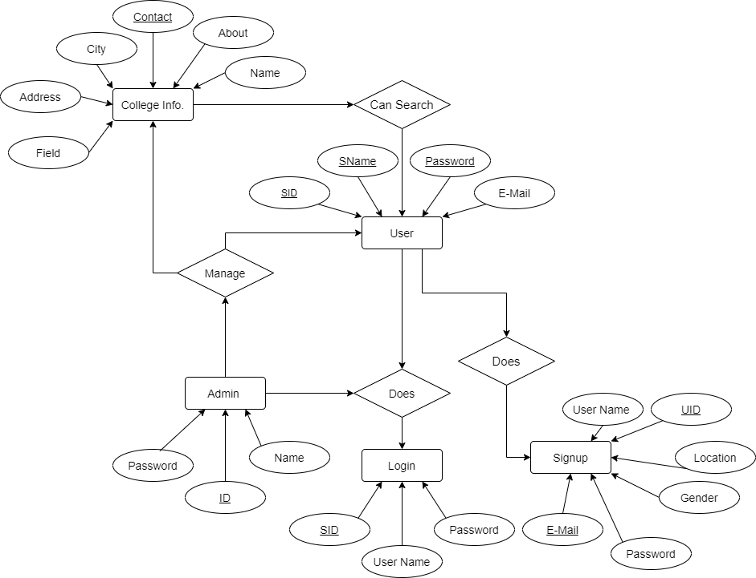**Fig. ER (Entity Relationship) Diagram**

* 1. **BEHAVIOURAL MODELING**
     + 1. **Data Flow Diagram :**

A data flow diagram (DFD) is a graphical representation of the “flow of data” through an information system, modelling its process aspects. A DFD is often used as a preliminary step to create an overview of the system without going into great detail, which can later be elaborated. DFDs can also be used for the visualization of data processing (structured design).

* + - 1. **Context Level Diagram (Level 0)**

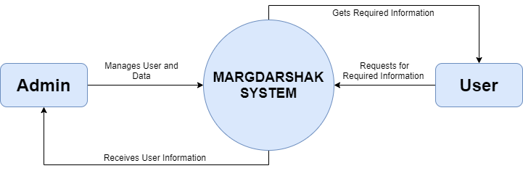

* + - 1. **DFD – Level 1**

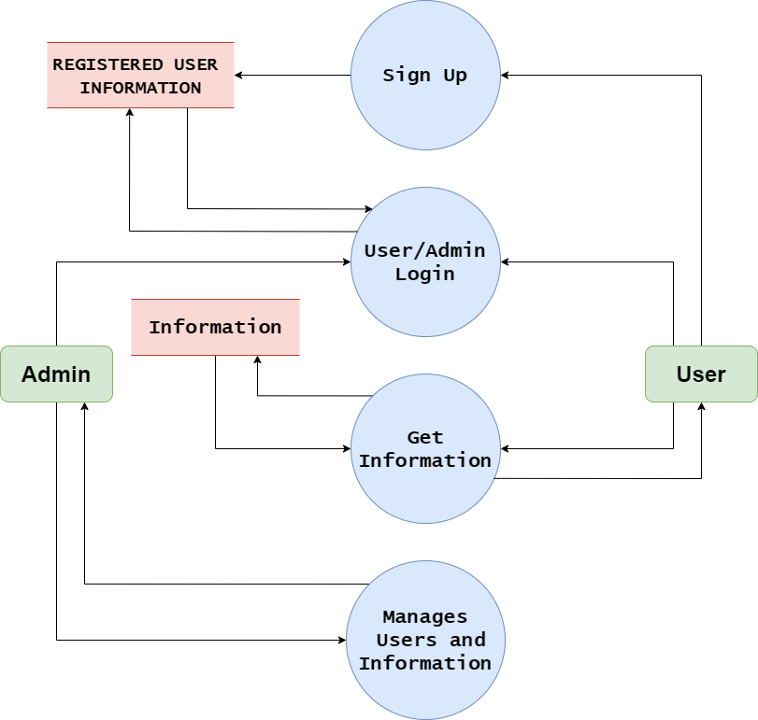

* + - 1. **DFD – Level 2**

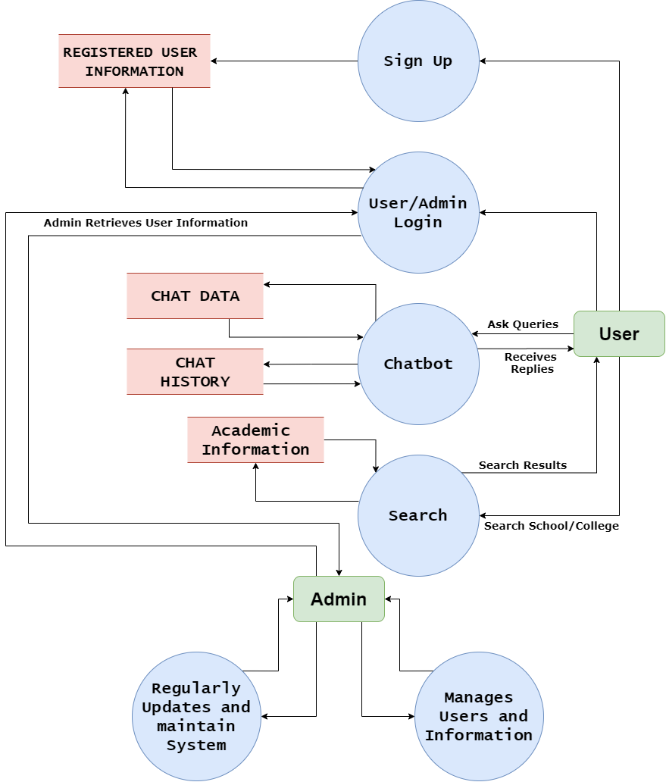

1. **SYSTEM DESIGN - UML**

**5.1 Sequence Diagram**

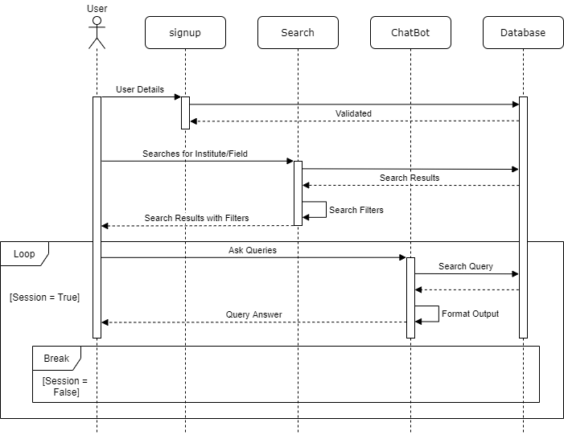A sequence diagram simply depicts the interaction between objects in sequential order i.e. the order in which these interactions take place. We can also use the terms event diagrams or event scenarios to refer to a sequence diagram. Sequence diagrams describe how and in what order the objects in a system function.

**Fig. Sequence Diagram**

**5.2 Activity Diagram**

An activity diagram is a **behavioural diagram** i.e. it depicts the behaviour of a system. An activity diagram portrays the control flow from a start point to a finish point showing the various decision paths that exist while the activity is being executed.

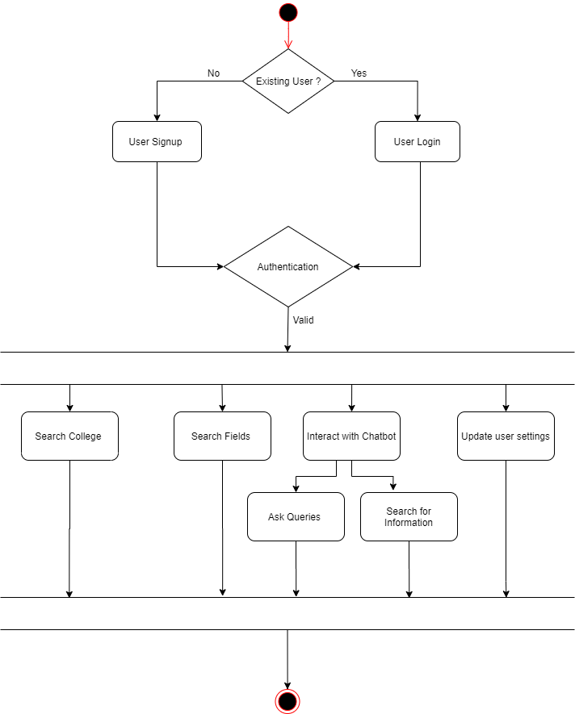**5.2.1 User Activity Diagram:**

**5.2.2 Admin Activity Diagram:**

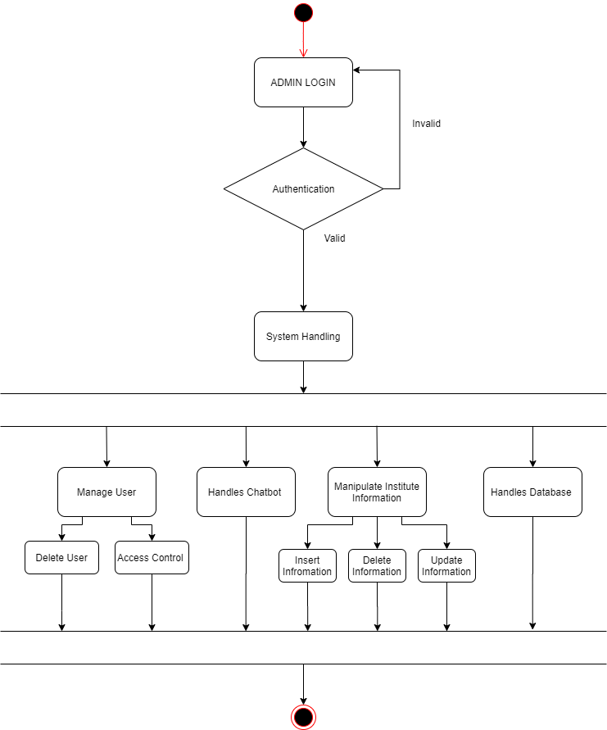

1. **System Interface Design**

**6.1 Graphical User Interface Design (Input-Output Forms):**

